**Project Outline** 5 June 2018

**Please submit this before leaving today.**

1. Which API are you going to use for your project?

<https://randomuser.me/documentation>

<https://currencylayer.com/documentation>

1. What are you going to display in your project page?

It will display 4~6 random for countries a list of 4 countries.

For each country the user will be able to get real-time currency quotes and request a currency exchange amount

1. Layout a schema for your project (models)

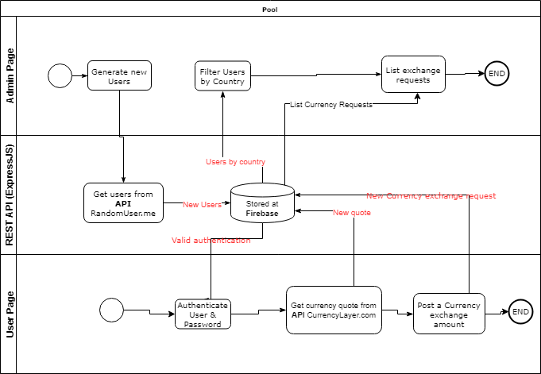

1. Draw a rough design of your project on the back of this page.

